**LAB 6: FATIGUE AND BRITTLE FRACTURE**

Keyvan Yeganeh - 23988165

Ratthamnoon Prakitpong - 63205165

Section C

Lab Date: October 25 , 2017

**Summary**

In this lab we explored the effects of temperature, fatigue, and defects on the behaviour of material. In the fatigue experiment, two metal specimen were placed in a machine in which they received repetitive rotations torsion. By observing the time taken for failure to occur, we can compare the difference in behaviour of the two metals, one which was given a sharp notch, and one which had a more smooth notch. In experiment two, we explored different ways of identifying external as well as internal defects in material. In the next experiment, we observed the effect of temperature on the ductility of steel, by observing its behaviour at the point of failure when it was struck by a heavy hammer. In the final experiment, a rifle was used to shoot bullets into sheet metal at different temperatures. In this experiment we observed the energy absorbed by the metal when struck by the bullet, thus verifying the relationship between temperature and fracture behaviour.

**Procedure**

See MECH 221/2 Lab Manual.

**Results**

**Table 1: Fatigue Test Result**

|  |  |  |  |  |
| --- | --- | --- | --- | --- |
| Fatigue Test | | | | |
| Specimen | Machine reading | Cycles to failure | Other measurements |  |
| Smooth | 126.8 | 31700 | Diameter(mm) | 6.35 |
| Notched | 32.3 | 8075 | Load(N) | 48.9 |
|  |  |  | Moment(Nmm) | 11198.1 |

**Table 2: Charpy Test Result**

|  |  |  |
| --- | --- | --- |
| Charpy Impact Test | | |
| Temperature(C) | Fracture Energy(J) | % Shear |
| 100 | 135 | 100 |
| -190 | 6 | 0 |

**Table 3: Ballistic Pendulum Test Result**

|  |  |  |  |
| --- | --- | --- | --- |
| Ballistic Pendulum Test | | | |
| Steel | | Aluminum | |
| T(C) | Angle(deg) | T(C) | Angle(deg) |
| 22.3 | 4.6 | 25 | 3.4 |
| -189.4 | 2.3 | -185 | 3.5 |
| -150 | 2.7 |  |  |
| -130.4 | 3 |  |  |
| -92.1 | 8.1 |  |  |
| -105 | 10.2 |  |  |
| -120 | 14 |  |  |

**Table 4: Non-destructive Test Result**

|  |  |  |  |  |  |
| --- | --- | --- | --- | --- | --- |
| Non Destructive Testing | | | | Key | |
| Specimen number | Flaw type | Location from numbered face(mm) | Detection method | N | None |
| 1 | N | 0 | 0 | S | Surface |
| 2 | S | 25 | DP | I | Internal |
| 3 | N | 0 | 0 | DP | Dye penetration |
| 4 | I | 28 | US | US | Ultrasonic |
| 5 | S | 40 | FMP | FMP | Fluorescent magnetic particle |
| 6 | I | 10 | US | MP | Magnetic particle |
| 7 | S | 15 | MP |  |  |
| 8 | N | 0 | 0 |  |  |
| 9 | I | 39 | US |  |  |
| 10 | S | 28 | DP |  |  |
| 11 | N | 0 | 0 |  |  |
| 12 | I | 25 | MP |  |  |

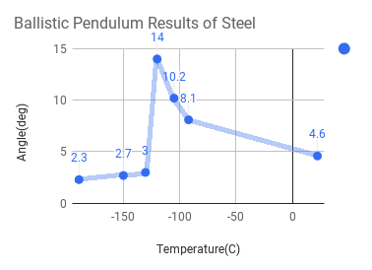

**Figure 1: Ballistic Pendulum Results of Steel**

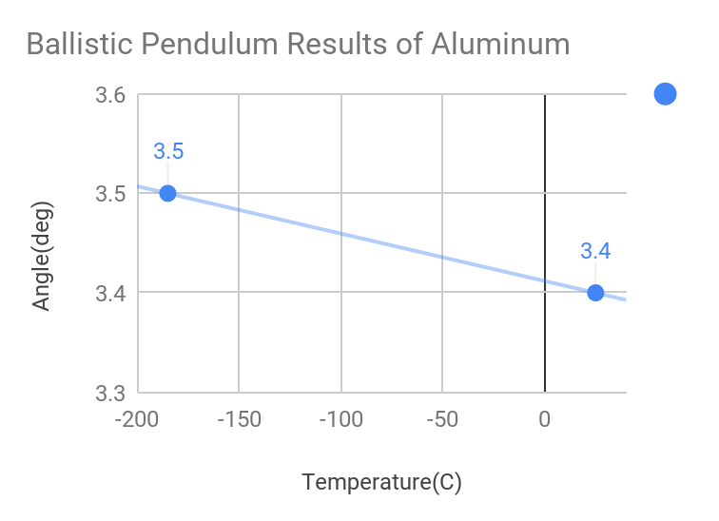

**Figure 2: Ballistic Pendulum Results of Aluminum**

**Questions**

1. 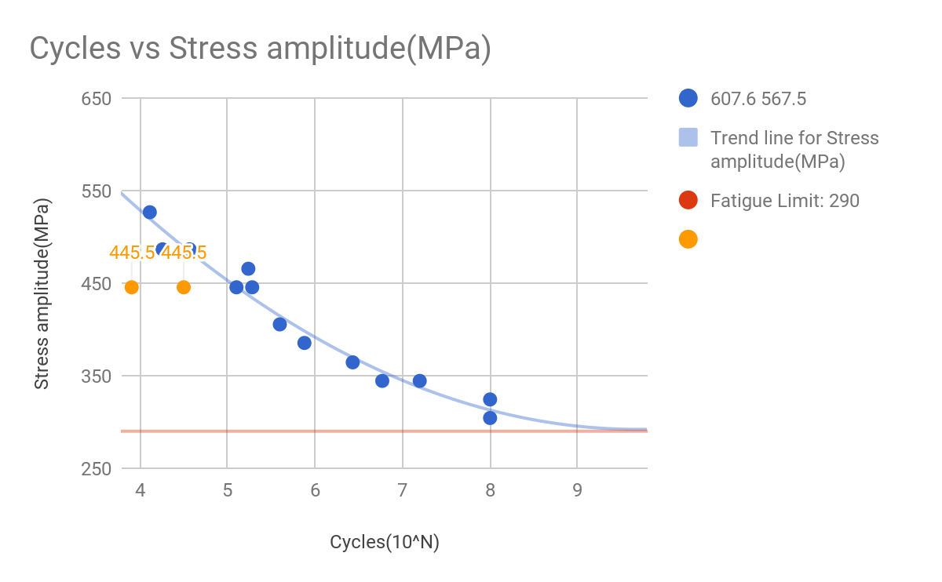**Figure 3: Cycles(10^N) vs. Stress amplitude of given data set**The fatigue limit was graphically determined to be 290MPa, which is where the trendline started to form an asymptote. Compared to ultimate tensile stress of 700MPa, the fatigue limit is only 41.4% of the ultimate tensile stress. The data from lab is shown in yellow on the graph. Please refer to Appendix A for calculations.
2. The data point of the notched specimen(leftmost yellow data point) is far from the curve because instead of evenly spreading out, stress concentrated on the sharp angle of the notch. This also explains why it took fewer cycles to shear; the notch provided an area for stress to concentrate and propagate shearing from. The stress concentration factor came out to be 1.44. Please refer to Appendix B for calculations.
3. In designing a structure subject to fluctuating stress, information from an S-N curve can be used as the graph shows the number of fluctuating stresses a given specimen can take, based on the load in each fluctuation. Therefore, if a specimen is to be receiving a given number of fluctuating stresses at a given load, the cross sectional area of the piece can be adjusted so that the stress at that given load is that or lower than the stress required. If aluminium was placed in the experiment, it would not withstand infinite fluctuations as aluminium does not have a fatigue limit.
4. Factors that affect fatigue strength include:

* Temperature
* Defects (cracks)
* Stress concentrations due to shape (notches, holes, etc.)
* Size
* Material properties (young’s modulus, ductility, strength, etc.)

1. Observing the deflection angle vs temperature graph for both steel and aluminium, (refer to figure 1 and 2), it can be seen that the ductile to brittle transition for steel is roughly -120 degrees celsius. Above this point, the material begins to behave in a ductile fashion. Since steel is a BCC metal, it makes sense that temperature as a higher effect on its ductility. Comparing this to aluminium, an FCC metal, it can be seen that for both tests on aluminum, the energy absorbed is roughly the same, showing that there is no ductile to brittle transition for aluminium. Aluminum atom dislocation are less affected by temperature.
2. **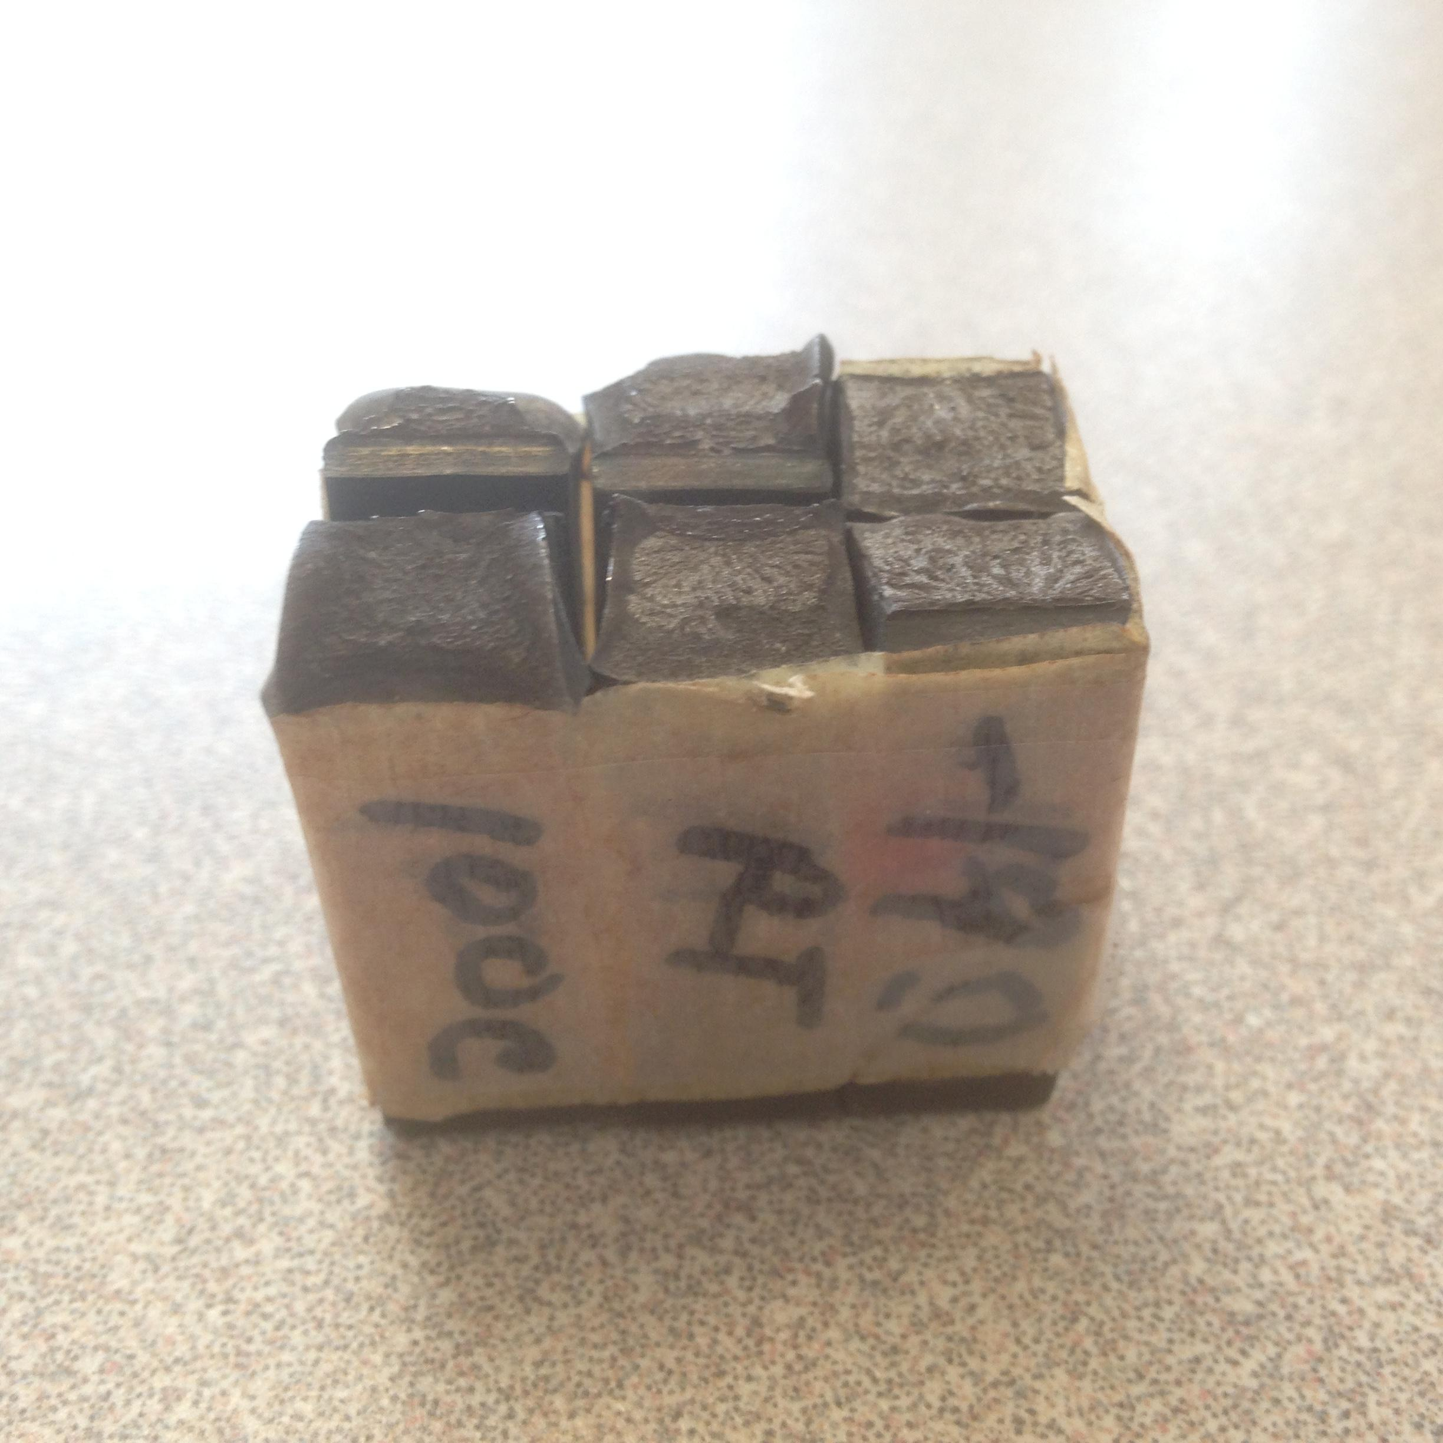  
   Figure 4: Photos of Charpy specimen at 100C(left) and -190C(right). Notice more crystalline shearing of -190C specimen, and more plastic deformation of 100C specimen.**  
   At 100C, we have estimated 100% shear and 135J absorbed; at -190C, 0% shear and 6J absorbed(refer to table 2). Looking at experimental data, we can conclude that higher percent shear correlates with higher energy absorbed. Theoretically, the energy a material can absorb before shearing, the higher is its ductility. Higher ductility is also linked to increased plastic deformation, which in our case is the percent shear.
3. If the Charpy test was duplicated using 0.1% steel at room temperature and at 100 degrees, we would observe the behaviour of steel past the point brittle to ductile transition. At a temperature of -190 degrees, the 0.4% steel specimen is fully brittle, thus undergoing 0% shear. If we use 0.1% steel which is more ductile than the 0.4%, we would observe ductile behaviour from the steel, and thus it would undergo 100% shear in the Charpy test.

**Appendixes**

**Appendix A:** Question 1 Sample Calculations

|  |  |  |  |  |  |  |
| --- | --- | --- | --- | --- | --- | --- |
| Given data | | | |  | Calculation method | |
| Cycles | Cycles(10^N) | Force(N) | Stress amplitude(MPa) | Stress amplitude(MPa) | Moment(Nm) | Load*0.229 |
| 3320 | 3.521138084 | 66.7 | 607.6 |  | Stress amplitude(MPa) | (10^-6)*32*Moment/(pi()*Diameter^3) |
| 4500 | 3.653212514 | 62.3 | 567.5 |  |  |
| 13000 | 4.113943352 | 57.8 | 526.6 |  |  |
| 18200 | 4.260071388 | 53.4 | 486.5 |  | Percent fatigue limit to UTS | (290/700)*100% |
| 37000 | 4.568201724 | 53.4 | 486.5 |  |
| 127000 | 5.103803721 | 48.9 | 445.5 |  |  |  |
| 173500 | 5.239299479 | 51.1 | 465.5 |  |  |  |
| 192000 | 5.283301229 | 48.9 | 445.5 |  |  |  |
| 397000 | 5.598790507 | 44.5 | 405.4 |  |  |  |
| 758000 | 5.879669206 | 42.3 | 385.3 |  |  |  |
| 2700000 | 6.431363764 | 40 | 364.4 |  |  |  |
| 5870000 | 6.768638101 | 37.8 | 344.4 |  |  |  |
| 15725000 | 7.196590654 | 37.8 | 344.4 |  |  |  |
| 100000000 | 8 | 33.4 | 304.3 |  |  |  |
| 100000000 | 8 | 35.6 | 324.3 |  |  |  |
| Fatigue Test |  |  |  |  |  |  |
| 31700 | 4.501059262 | Smooth |  | 445.5 |  |  |
| 8075 | 3.907142531 | Notched |  | 445.5 |  |  |

**Appendix B:** Question 2 Calculations

|  |  |  |  |  |
| --- | --- | --- | --- | --- |
| Calculations | | Calculation method | | |
| Cycles of notched specimen | 8075 | Theoretical stress | Propagate the amount of experimental cycle on line of best fit. In this case, we found the equation of the line and simply plug the cycles in. | |
| Theoretical stress(Pa) | 641989500 |
| Real stress(Pa) | 445474933 |
| K | 1.44 | Equation of line of best fit | 9.8672x^2-174.43x+1079.63 | |
|  |  | K | (Theoretical stress)/(Real stress) | |